Further actions  If you are dissatisfied with the outcome of your complaint you can seek further guidance from:  NHS England  PO BOX 16738  Redditch B97 9PT  Tel: 03003 112233  england.contactus@nhs.net  Or alternatively complain to the:  Parliamentary Health Service Ombudsman  Milbank Tower  Milbank  London SW1P 4QP  Tel: 0345 015 4033  www.ombudsman.org.uk | Wigmore Medical Centre  114 Woodside  Wigmore, Gilligham, Kent, ME8 0PW  01634 231752 wigmore.medicalcentre@nhs.net |  | The Complaint Process  - Wigmore Medical Centre
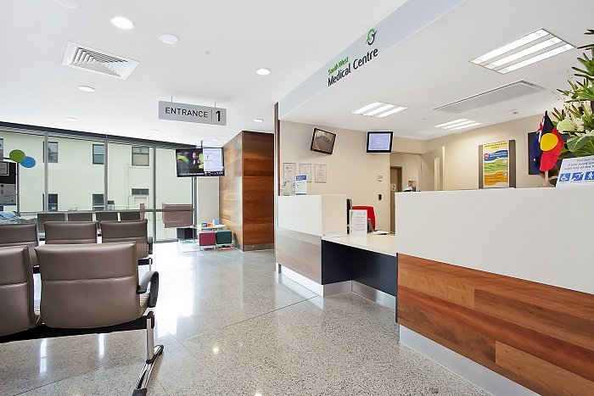  Talk to us  Every patient has the right to make a complaint about the treatment or care they have received at Wigmore Medical Centre.  We understand that we may not always get everything right and by telling us about the problem you have encountered, we will be able to improve our services and patient experience.  Who to talk to  Most complaints can be resolved at a local level. Please speak to a member of staff if you have a complaint; all our staff are trained to handle complaints effectively. Alternatively, ask to speak to the Complaints Manager, Kelly Mills, Practice Manager. | At Wigmore Medical Centre the  Complaints Manager is :  Kelly Mills, Practice Manager and they are supported by the Responsible Officer who is:  Dr Reema Patel.  A complaint can be made verbally or in writing. A Complaints Form is available from reception. Additionally, you can complain via email to: Wigmore.medicalcentre@nhs.net  Time frames for complaints  The time constraint on bringing a complaint is 12 months from the occurrence giving rise to the complaint, or 12 months from the time you become aware of the matter about which you wish to complain.  The complaints manager will respond to all complaints within three business days. Furthermore, they will provide regular updates for you regarding your complaint, whilst aiming to have the complaint completely resolved within 56 days. |  | Investigating complaints  Wigmore Medical Centre will investigate all complaints effectively and in conjunction with extant legislation and guidance.  Confidentiality  Wigmore Medical Centre will ensure that all complaints are investigated with the utmost confidentiality and any documents are held separately from the patient’s healthcare record.  Third party complaints  Wigmore Medical Centre allows a third party to make a complaint on behalf of a patient. The patient must provide consent for them to do so. A Third Party Patient Complaint Form is available from reception.  Final response  Wigmore Medical Centre will issue a final formal response to all complainants which will provide full details and the outcome of the complaint. Further information is detailed in our practice policy.

